1.
A student carried out an experiment to show that the acceleration a of an object is proportional to the force F applied.
The student recorded the following results.
F (N) | 0.2 | 0.4 | 0.6 | 0.8 | 1.0 | 1.2
a (m s⁻¹) | 0.72 | 1.39 | 2.11 | 2.76 | 3.47 | 4.22

- Draw a labelled diagram of the apparatus used in this experiment.
- What measurements did the student take to calculate acceleration?
- State one precaution the student took to ensure an accurate result.
- Use the data in the table to draw a graph on graph paper of F against a.
- Explain how your graph shows that acceleration is proportional to force.

2.
A student carried out an experiment to measure the focal length f of a concave mirror.
She measured the object distance u to be 20 cm and the image distance v to be 61 cm.
- Draw a labelled diagram of the apparatus used in this experiment.
- On your diagram, indicate the object distance u and the image distance v.
- Describe how the student found the position of the image.
- State the formula used to calculate the focal length f.
- Calculate f.
- Describe how the student could have improved the experiment.

3.
A student carried out an experiment to measure the specific latent heat of fusion of ice.
He added ice at 0 °C to water in a copper calorimeter.
The following results were recorded.
Mass of empty copper calorimeter = 0.083 kg
Mass of calorimeter + water = 0.181 kg
Mass of ice = 0.008 kg
Initial temperature of calorimeter + water = 23 °C
Final temperature of calorimeter + water + melted ice = 16 °C
Below is a diagram of the apparatus used in this experiment.
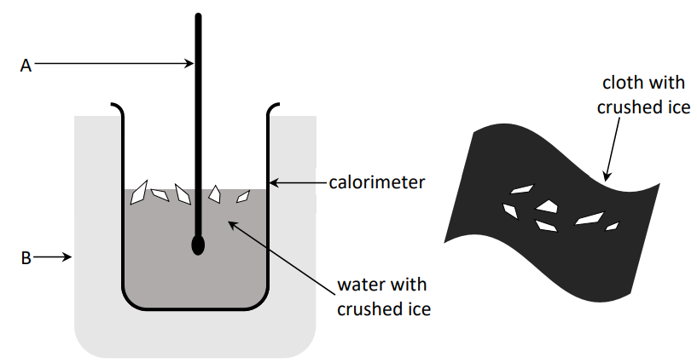

- Name the piece of equipment labelled A.
- Name the piece of equipment labelled B.
- Why did the student crush the ice before adding it to the calorimeter?
- What was the cloth used for in this experiment?
- Calculate the fall in temperature of the calorimeter and water.
- Calculate the mass of the water.
- Using the formula mcΔθ and your answers to (v) and (vi), calculate E, the heat lost by the water and the calorimeter.
- Calculate the rise in temperature of the ice.
- Calculate the value for l, the specific latent heat of fusion of ice.
Note: E = m_{ice}l + m_{ice}c_{water}Δθ_{ice}
specific heat capacity of copper = 390 J kg^{–1}K⁻¹; specific heat capacity of water = 4180 J kg^{–1} K^{–1}

4.
A student carried out an experiment to determine the speed of sound in air. The student set a tuning fork vibrating and measured the length l of a column of air when the air was vibrating at its fundamental frequency f. The experiment was repeated for different frequencies.
f (Hz) | 256 | 288 | 320 | 341 | 384 | 480
l (m) | 0.33 | 0.29 | 0.27 | 0.25 | 0.22 | 0.18
The student recorded the following results.

- Draw a labelled diagram of the apparatus used in this experiment.
- Indicate on your diagram the length that the student measured.
- How did the student find the frequency values?
- The student knew that the column of air was vibrating at its fundamental frequency because resonance had occurred.
- How did the student know that resonance had occurred?
- For each value of l in the table above, calculate the value of $\frac{ 1}{l}$ to 2 decimal places.
- Draw a graph on graph paper of f against $\frac{ 1}{l}$ .

5. In an experiment to determine the resistivity of a nichrome wire, a student measured the resistance R and the length l of the wire. She repeated this for different lengths of wire.
l (cm) | 20 | 30 | 40 | 50 | 60 | 70
R (Ω) | 0.08 | 0.12 | 0.17 | 0.21 | 0.25 | 0.29
d (mm) | 2
She also measured the diameter d of the wire.
The student recorded the following results.

- Name the apparatus used in this experiment to measure (a) the length of the wire (b) the resistance of the wire and (c) the diameter of the wire.
- How did the student check that the wire had the same diameter throughout its length?
- Use the data in the table to draw a graph on graph paper of length l against resistance R.
- State the relationship between l and R.
- State the formula used to calculate ρ, the resistivity of the wire.

6. Answer any eight of the following parts (a), (b), (c), etc.
  - What is meant by the moment of a force?
  - A car accelerates from a speed of 17 m s^{–1}to a speed of 28 m s^{–1} in a time of 8 s.
Calculate the acceleration of the car.
  - Convert 30 °C into kelvin (K).
  - Which of the following is the unit of work?
joule watt farad metre
  - Name an instrument used to measure voltage.
  - An object has a height of 2 cm. Its image in a mirror has a height of 5 cm.
Calculate the object’s magnification.
  - Explain the difference between heat and temperature.
  - What are complementary colours of light?
  - Describe how infrared radiation can be detected.
  - What is meant by capacitance?
  - Describe how white light can be separated into its constituent colours.
  - State what each letter in Einstein’s famous equation E = mc² stands for.

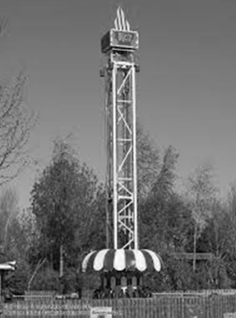
2023 Question 7 [Ordinary level]
A big drop is an amusement ride where a carriage with passengers is lifted to the top of a large vertical tower and then released to fall down the tower before it brakes and comes to rest.
- As the carriage travels to the top, the carriage is gaining potential energy. What is meant by potential energy?
- Draw a diagram of the forces acting on the carriage as it travels up the tower at a constant velocity.
- The carriage is dropped from a height of 37 m above the braking zone. The mass of the carriage is 6200 kg.
- Calculate the potential energy the carriage had before it was dropped.
- What is the main energy conversion that takes place as the carriage falls?
- Calculate the velocity of the carriage when it has fallen 37 m.
- Calculate the time it takes the carriage to fall 37 m.
- Draw a diagram of the forces acting on the carriage as it falls.
- Draw a velocity-time graph for the motion of the carriage from when it was dropped to when it comes to rest.
acceleration due to gravity = 9.8 m s^{–2}

2023 Question 8 [Ordinary level]
The diagram below shows how a ray of light travels through a rectangular glass block.
- What is meant by refraction of light?
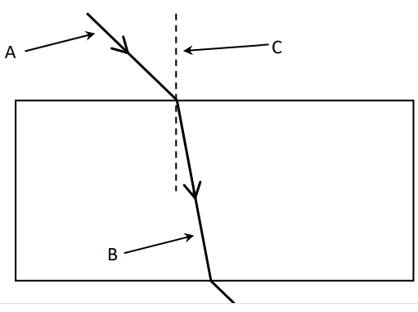
- Name A, B and C.
- Copy the diagram into your answerbook and label the angle of incidence i and the angle of refraction r.
- The refractive index of the glass block is 1.5. Calculate the angle of refraction when the angle of incidence is 35°.
- Refraction also occurs when light travels through a lens.
Draw a converging lens and draw a ray diagram to show how the lens forms a real image.
- An object is placed 25 cm in front of a converging lens of focal length 15 cm.
- Calculate the position of the image formed.
- Converging lenses can be used in glasses to correct a sight defect. Which sight defect is corrected using a converging lens?

2023 Question 9 [Ordinary level]
Brick is considered one of the best construction materials in the world for a number of reasons. One reason is that brick is a better insulator than many other building materials.
- Heat is transferred through a wall by conduction. Name two other ways in which heat can be transferred.
- What is meant by the U-value of a material?
- A wall has an area of 66 m² and a U-value of 0.31 W m^{–2} K^{–1}. The temperature difference between inside and outside the wall is 15 °C. Calculate how much heat energy is transmitted through the wall every second.

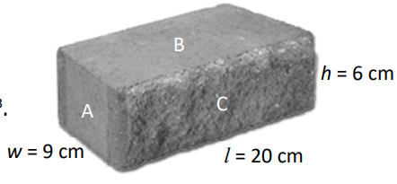
Another reason for bricks being such a popular building material is that that they are durable and strong. A brick has length l = 20 cm, width w = 9 cm and height h = 6 cm, as shown in the diagram.
The brick has a mass of 2 kg.
- Calculate the volume of the brick in cm³.
- Calculate the density of the brick in g cm^{–3}.
- The bricks are stacked to build a wall. On which side, A, B or C, should a brick be stacked so that it exerts the least amount of pressure on the bricks below it?
- Explain your answer.

Brick is a sustainable material. Factories that make bricks are moving away from non-renewable energy sources and are using alternative energy sources instead.
- What is meant by non-renewable energy?
- State an example of a renewable energy source.
- Bricks alone are not enough to meet today’s heat retention standards.
State two ways in which you can reduce heat loss from your home.

2023 Question 10 [Ordinary level]
The source of every sound is a vibration. Sound travels as a wave.
As a sound wave moves it interacts with its environment in four ways, one of which is reflection.
- What is meant by reflection?

- Sound also undergoes refraction as it moves from one medium to another.
What causes sound to refract as it moves from one medium to another?

- When two sound waves meet they can undergo interference.
Describe a laboratory experiment to show that sound waves undergo interference.

- Sounds waves can undergo diffraction as they pass through a doorway or a window.
This is why we can hear around corners.
What is meant by diffraction?

- Light waves can undergo polarisation but sound waves cannot.
Why do sound waves not undergo polarisation?

A standing wave is set up on a string as shown so that the distance between points A and B is 45 cm.
The waves on the string are travelling with a speed of 400 m s^{–1}.

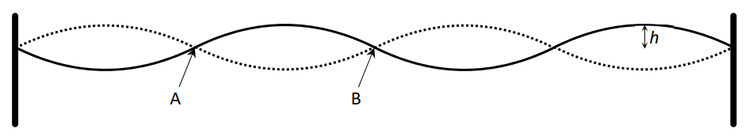
- What name is given to points A and B?
- What name is given to height h?
- Calculate the wavelength of the wave.
- Calculate the frequency of the wave.

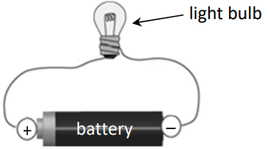
2023 Question 11 [Ordinary level]
Electric current is the movement of charged particles through a conductor.
- What is an electrical conductor?
- Name an instrument used to measure electric current.
- Draw a circuit diagram for the arrangement of apparatus shown in the diagram on the right.
- Draw a circuit diagram to show two light bulbs connected in parallel across a battery.
Note: You may refer to the electrical circuit symbols on pages 72 to 78 of the Formulae and Tables booklet
when answering parts (iii) and (iv).
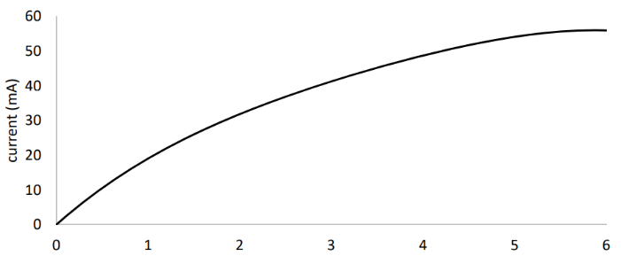
- Two light bulbs connected in parallel have resistances of 5 Ω and 4 Ω.
Calculate the total resistance of the two light bulbs.
- Calculate the total current flowing in this circuit if the battery had a voltage of 12 V.

The relationship between current and voltage for a filament bulb is shown in the graph below.

- Explain the shape of the graph.
- Sketch the graph of current against voltage for a metallic conductor held at constant temperature.
- The charged particles that carry current through a metallic conductor are electrons.
- Name the charged particles that carry current through an ionic solution such as copper sulfate solution?

2023 Question 12 [Ordinary level]
An electron is a negatively charged subatomic particle.
- Name a positively charged subatomic particle.
- Name a neutral subatomic particle.
- Draw a labelled diagram of an atom. Include in your diagram the names and locations of the subatomic particles of the atom.
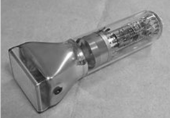
The picture on the right is of a cathode ray tube. A beam of electrons is produced in a cathode ray tube.
- How are the electrons produced in a cathode ray tube?
- How can the beam of electrons be deflected in a cathode ray tube?
- How is the beam of electrons detected in a cathode ray tube?

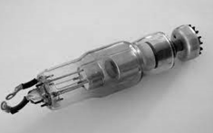
- The picture on the right is of an X-ray tube. A beam of high speed electrons is used to produce X-rays in an X-ray tube.
How are the electrons accelerated to high speeds in an X-ray tube?

Tungsten is often used as the target in an X-ray tube because it has a high melting point.
- Why does the target in an X-ray tube need to have a high melting point?
- X-rays are a type of electromagnetic radiation. They travel at a speed of 3 × 10⁸ m s⁻¹.
Calculate the wavelength of an X-ray that has a frequency of 5.5 × 10¹⁷ Hz.
- Name one other type of electromagnetic radiation.

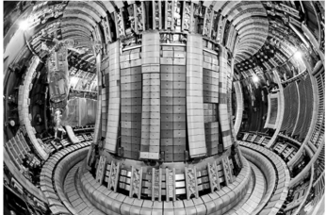
2023 Question 13 [Ordinary level]
Read the following passage and answer the questions below.
It was recently announced that a team of researchers at the Joint European Torus tokamak reactor near Oxford generated the highest sustained energy pulse ever created using nuclear fusion, the joining of two atomic nuclei with the release of energy.
If researchers can harness nuclear fusion, the process that powers the Sun, it promises to provide a near-limitless source of clean energy. But so far no experiment has generated more energy than has been put in, due to the huge force of electrostatic repulsion between nuclei. These results do not change that, but they suggest that scientists should eventually be able to reach this goal.
To break the energy record, the scientists used a fuel made of equal parts tritium and deuterium.
Tritium is a rare and radioactive isotope of hydrogen, meaning it has the same atomic number as normal hydrogen but a different mass number. When tritium undergoes nuclear fusion with the isotope deuterium, the reaction produces more energy than a reaction involving deuterium only.
In this experiment, 59 MJ of energy was produced during a fusion pulse that lasted 5 s. This pulse generated more than twice the power of the previous record for nuclear fusion.
Adapted from: www.nature.com
- What is meant by nuclear fusion?
- Why is there a huge force of electrostatic repulsion between two nuclei that are brought close to each other?
- The scientists used isotopes of hydrogen in this experiment. What are isotopes?
- The symbol for tritium is $H_{1}^{3}$.
  - How many protons are in an atom of tritium
  - How many neutrons are in an atom of tritium?
- Tritium decays by beta emission. What is the daughter nucleus when an atom of $H_{1}^{3}$emits a beta particle?

- In this experiment, 59 MJ of energy was produced during 5 s.
Calculate the power generated.

- Nuclear power plants currently use nuclear fission, not nuclear fusion.
What is meant by nuclear fission? (7)
- Large amounts of money are being invested into nuclear fusion research.
Why is there such interest in replacing nuclear fission with nuclear fusion?

2023 Question 14 (a) [Ordinary level]

A train has a mass of 180 000 kg and is travelling at a speed of 4 m s^{–1}.
- Calculate the momentum of the train. Include units in your answer.
The train then joins together with a carriage of mass 85 000 kg which is at rest.
- What is the momentum of the carriage before the coupling?
- Explain your answer.
- Calculate the initial velocity of the train after it joins with the carriage.

- The train then accelerates to a speed of 22 m s^{–1}. It maintains this speed for 8 minutes.
Calculate the distance travelled by the train over the 8 minutes.

2023 Question 14 (b) [Ordinary level]
Light travels through an optical fibre using total internal reflection.
- Sketch the path of a ray of light through an optical fibre.
- Describe a laboratory experiment to demonstrate total internal reflection.
- The critical angle of the glass in an optical fibre is 43.6°.
Calculate n, the refractive index of the glass.
- State one use of an optical fibre.

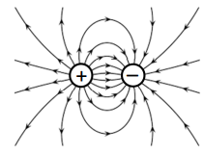
2023 Question 14 (c) [Ordinary level]
The diagram shows the electric field around two oppositely charged particles.
- Draw the electric field lines around two positively charged particles held close to each other.

- The force between two electric charges is calculated using Coulomb’s law.
Coulomb’s law is an example of an inverse square law.
Describe what is meant by an inverse square law.

- Electric charge builds up on the dome of a Van de Graaff generator.
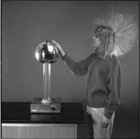
Describe a laboratory experiment that uses a Van de Graaff generator to show that charge resides on the outside of a hollow metal conductor.

- The picture on the right shows a student touching a Van de Graaff generator.
Explain why her hair is standing up.

2023 Question 14 (d) [Ordinary level]
A current-carrying conductor has a magnetic field around it.
- What is a magnetic field?
- Describe a laboratory experiment to plot the magnetic field around a current-carrying conductor.
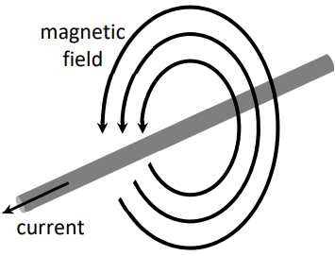
- When a current-carrying conductor is placed in an external magnetic field, it experiences a force.
The magnitude of the force F is proportional to the magnitude of the magnetic flux density B. The force may be calculated using the formula F = IlB.
A straight piece of wire of length 1.8 m carrying a current of 3 A experiences a maximum force of 11 N when it is placed in a uniform magnetic field.
Calculate the magnetic flux density.

- Magnetic flux density is an example of a vector quantity.
Name another example of a vector quantity.

